SummerLands Project

Does your community group have an idea for a temporary pop-up park, container garden, community event space or art installation?

Ramsey County is making some land available for seasonal community use. Apply to manage a piece of land from May 2021 to October 2021. The application begins on page four (4) of this document.

Applications must be received by Sunday, February 28, 2021.
- Email applications to Sia Xiong at sia.xiong@co.ramsey.mn.us OR
- Drop off applications in Suite 250 in the Ramsey County Courthouse (15 W. Kellogg Blvd, St. Paul, MN 55102). This is the same building as St. Paul City Hall.

REQUIREMENTS
- Seasonal use, all uses must end before October 31 and land must be returned to the previous state.
- Application needs to be from or sponsored by a non-profit organization.
- Non-profits with liability insurance over $1 million are eligible to apply.
- Have a plan and funding. Ramsey County is not offering funding, just access to the land.
- One-time use is discouraged.
- All land is smoke-free, tobacco-free, drug-free and e-cig free.

- No consumption of alcohol is permitted on the land.
- The land must remain open to the public.
- Must conform with all city ordinances including noise, sound amplification, etc.
- Must keep site up to city code, this includes grass length, debris, and overall cleanliness.
- Land must be free of hate speech, religious speech (separation of church and state), and strong political statements.

ACCEPTABLE USES
- Temporary community event space
  - Performance space
  - Meeting space
  - Market space
  - Festival space

- Temporary park or greenspace
  - Seating/rest areas
  - Off-the-ground compost container
  - Exercise space
  - Yard games

- Temporary art installations

- Temporary container garden
  - Sites do not have water sources
  - No gardening in the soil on the eligible land
  - Containers must be above ground and soil from selected land cannot be used
  - Additional gardening resources are on our website: ramseycounty.us/SummerLands

AVAILABLE LAND
This year, there are two parcels of land available for temporary use. If you are interested in other areas on this site, please contact Sia Xiong (sia.xiong@co.ramsey.mn.us).

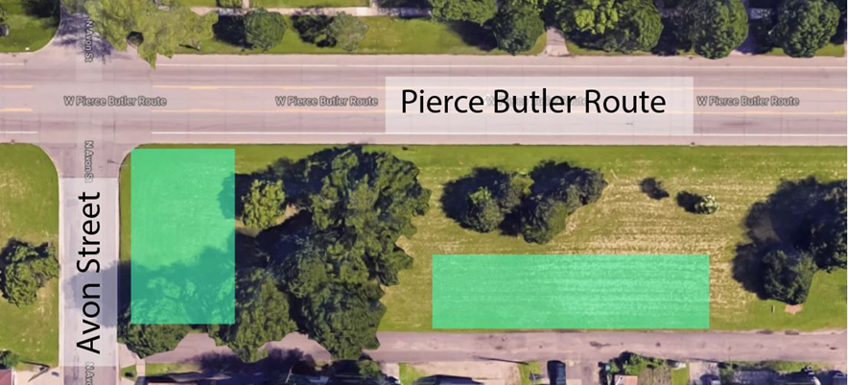
Pierce Butler Route at Avon Street
This piece of land is owned and managed by Ramsey County’s Public Works and is road right-of-way. The land is in Saint Paul’s Frogtown neighborhood and can be accessed on Avon Street. Water access is not available on this site. The green squares are recommended areas because they are relatively flat.

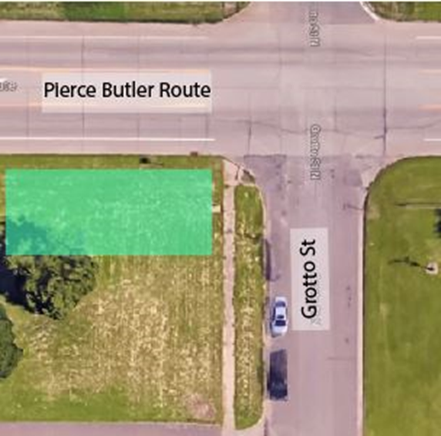
Pierce Butler Route at Grotto Street
This piece of land is owned and managed by Ramsey County and is road right-of-way. The land is in Saint Paul’s Frogtown neighborhood and can be accessed on Grotto Street. Water access is not available on this site. The green squares are recommended areas because they are relatively flat.

REVIEW TEAM
Applications are reviewed by cross-department staff, which may include the following departments:
- Public Health
- Property Management
- Property Tax and Election Services
- Public Works
- Community and Economic Development
- County Manager’s Office
- County Attorney’s Office
- Risk Management

CRITERIA TO EVALUATE APPLICATIONS

Total Possible Points: 65

Section | Points | Criteria | Score
The sponsoring non-profit organization is based in the surrounding neighborhood. | 5 | Non-profit is located in or headquartered in the community
 | 1-4 | Non-Profit isn’t located in but describes strong relationships with surrounding community
 | 0 | Non-profit is not located in neighborhood and doesn’t describe strong relationships with surrounding community
How clear, realistic, and actionable is the applicant’s proposed plan? | 20 | The proposed plan falls under the list of acceptable uses and can meet all requirements, such as maintenance and ending the use by the end of October
 | 8-15 | The proposed plan falls under the list of acceptable uses but may have a hard time meeting all requirements. May need additional resources to be successful
 | 0 | The plan is not considered an acceptable use and may have a hard time meeting all requirements
Group includes member(s) who live or work in the surrounding neighborhood and/or describes strong relationships with surrounding community. | 13-15 | All or almost all members live or work in the surrounding neighborhood
 | 7-12 | Some members live in the surrounding neighborhood or describe strong existing relationship with surrounding community
 | 0-6 | Group members do not live or work in neighborhood, and do not describe strong relationships with the surrounding community
Group plans to actively use land. | 10 | Frequently or very infrequently (daily, weekly or bi-weekly)
 | 5 | Occasionally or infrequently (once per month)
 | 0-2 | Very infrequently (less than once per month, or single event)
Plan for communications. | 10 | Robust – could include many, diverse mediums and audiences, such as other non-profits, other community coalitions, culturally-specific groups that reflect the community, nearby residents, schools, social media, local newspapers, radio, other media outlets
 | 5-9 | Traditional engagement/communication plan – plans to reach out to existing community organizations, their existing membership and use social media. Less focused on multiple approaches
 | 0-4 | Weak communication plan – offers little detail on how they will reach out to the surrounding community and nearby residents
Will the land be open to all interested residents? | 5 | Yes, the land is open for all interested participants
 | 0 | No, the land will be closed off to the public
SummerLands Application

Are you a non-profit sponsoring your proposed activity? Non-profit organizations with liability insurance of $1 million are eligible to apply. Please attach organization’s W-9 with your application.
☐ Attached organization’s W-9 (required)

Name of Non-profit organization: Click or tap here to enter text.

Address of non-profit organization: Click or tap here to enter text.

Non-profit contact person: Click or tap here to enter text.

Non-profit contact information (phone or email): Click or tap here to enter text.

Contact Person for Application (if different from above): Click or tap here to enter text.

Email address of contact person (if different from above): Click or tap here to enter text.

Which piece of land are you applying for? (You may apply for more than one):
☐ Pierce Butler at Avon Street
☐ Pierce Butler at Grotto Street

What does your group propose to do with this piece of land? Please describe your proposed program for seasonal use (May through October 31). Please consult the list of acceptable uses and details on the available land.
Click or tap here to enter text.

How often will your group use this piece of land? (For example: weekly events; daily with a container garden, pop-up park, or art park) One-time use is discouraged.
Click or tap here to enter text.

Describe the membership of your group or organization. Do they live and work in the surrounding community? Do they have existing relationships with the surrounding community?
Click or tap here to enter text.

Is the proposed program for this piece of land open to all interested residents?
Click or tap here to enter text.
Describe or list how you will communicate, engage and advertise your proposed program to the surrounding community, nearby neighbors and other community organizations. Also, describe or list who you plan to communicate and engage with. (We encourage communication with neighbors, community organizations, culturally-specific groups that reflect the surrounding community, schools, businesses, local media and on social media.)
Click or tap here to enter text.

Applications must be received by Sunday, February 28, 2021.
- Email applications to Sia Xiong at sia.xiong@co.ramsey.mn.us OR
- Drop off applications in Suite 250 in the Ramsey County Courthouse (15 W. Kellogg Blvd, St. Paul, MN 55102). This is the same building as St. Paul City Hall.

