Career Coach:
Tips and Resources for Manufacturing

Manufacturing Resume Tips
- Show updated work history.
- Put resume in PDF format, not Word.
- Call the recruiter after you apply, contact the company and ask for HR.
“I applied for a position and am interested in working for your company.”
- Non-native English speakers should apply.
- Justice involved individuals should apply.
- Ensure skills are clear and evident on the resume - bold at the top of the resume.
- Everyone should have a LinkedIn profile.
- Use a “Professional Summary” rather than a cover letter or a “Resume Objective” - Indicate why you are applying for this position.
Resources
Labor Market Information
DEED LMI Office
https://mn.gov/deed/data/lmi-help/labor-market-experts/
Occupational Employment and Wage Statistics (OES- DEED)
https://mn.gov/deed/data/data-tools/oes/
ONET Online Manufacturing Career Cluster
https://www.onetonline.org/find/career?c=13

My Next Move
Comprehensive career exploration including KSA’s, Education, Job Outlook, ONET Interest Profiler and many videos.
https://www.mynextmove.org/
My Next Move Team Assembler
https://www.mynextmove.org/profile/summary/51-2092.00

Careerwise MN State
Exploration, connections to education programs, labor market info, financial aid and more all in one place.
https://careerwise.minnstate.edu/

Manufacturing Month
Labor market information for MN, transferable skills for manufacturing and events.
https://www.careerforcemn.com/2022ManufacturingMonthEvents
CareerForce MN YOUTUBE Channel has recordings of past events.
Tours at manufacturers across the state.
https://mnmfg.org/statewidetour/
www.mfgday.com/events/manufacturing-day-open-house/

DEED Career Pathways Tool
Click the icons for the specific industry, then click the specific occupation from the list for a full summary page.
https://www.careerforcemn.com/industry/manufacturing

Career One Stop
Lots of career videos from https://www.careeronestop.org/
https://www.youtube.com/playlist?list=PL5AAyLKIyw_p8fO0ujMeOyWnDWNOKH8s5

DEED YOUTUBE Channel (search Manufacturing)
https://www.youtube.com/user/deedminnesota
https://www.youtube.com/user/deedminnesota/featured
Manufacturing Round Table 2020

Industry Associations (learn about the industry)
Enterprise Minnesota
https://www.enterpriseminnesota.org/
MPMA
https://www.mpma.com

Training
Minnesota State Advanced Manufacturing Center of Excellence
https://mnmfg.org/
https://mnmfg.org/students/manufacturing-career-pathway/ Manufacturing Career Video

CareerForceMN.com
Occupational skills training page- DEED and partners add listings.
https://www.careerforcemn.com/training-programs
Pathways to Prosperity grantee training list from CareerForceMN.com.
https://www.careerforcemn.com/pathways-prosperity
Career and Education Explorer (ETPL)- find courses that WIOA funds may pay for.
https://mn.gov/deed/data/lmi-help/labor-market-experts/

DOLI Apprenticeships
Many employers listing manufacturing apprenticeships across the state.
https://secure.doli.state.mn.us/apprenticeshipsponsor/
Other employers may not use formal apprenticeships with DOLI but have their own training programs.
Job Connect Training Dashboard
Search by occupation/sector category, almost all free training.
https://www.ramseycountymeansbusiness.com/workforce/workforce-training-dashboard

Quick Coach Guide
This guide is designed to help Career Counselors have exploratory conversations with job seekers regarding their career interests and preferences to work in Manufacturing. For 15-30 minute consultations, pick lines of inquiry and specific questions as they resonate with the job seeker.

Overview: We’ll talk about your:
- Goals and interests.
- Pathways.
- Resources and how I can help.
- Referrals to more services and support.

Relationship building/intros:
- How did you hear about these opportunities?
- What excites you most about manufacturing?
- Do you have friends or family in manufacturing?
- Do you see yourself working with a specific company, product, equipment, or application?

Assess interests:
- What questions do you have about manufacturing?
- What positions interest you?
- What employers interest you?
- Are there specific manufacturing career pathways that interest you?

Assess qualifications in relation to minimum qualifications and current demand:
- Experience.
- Education/training.
- Certifications.
- Other quals (physical demands, justice involved backgrounds, etc.).
- May work weekends and nonstandard shifts.

Other Coach Inquiry:
- Let’s talk about prepping for applications/resumes/virtual or in person interview and follow up. Where would you like to start first?
- What access to technology do you currently have? (Be sure to have technology resources to participate in online career fairs.)
- What are your resource and support needs? (referral to community resources.)
- Referral to workforce programs (Adult, Dislocated Worker, Youth, Voc. Rehab).
- How to stay in touch/follow up to ensure the job seekers got a warm connection/hand off and/or can get further support from quick coaching.

Manufacturing Career Terminology
https://gomingo.io/manufacturing-glossary-key-terms/
Manufacturing Career Pathway Graphics
Central Minnesota Jobs and Training
https://www.cmjts.org/careers-in-manufacturing/
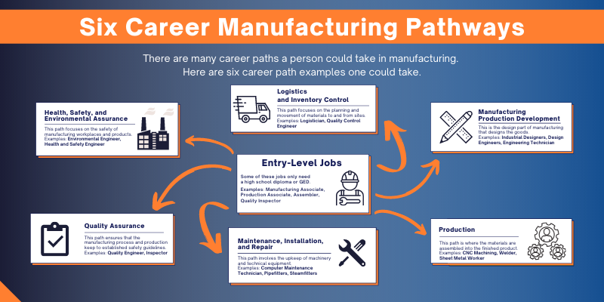
Graphic source: https://www.mau.com/career-tips/different-career-pathways

9/26/22 Workforce Solutions

