

5287 Otter Lake Road, White Bear Township, MN 55110

Phone: 651-266-0360   
Email: tamarack@co.ramsey.mn.us **www.TamarackNatureCenter.org**

**Returning**

**Junior Assistant Naturalists**

2022 Day Camp Adventures Team! Welcome Back!

• Volunteers must be 14-17 years of age.

• Enjoy working with children, be willing to play, get your hands dirty and be active in all aspects of camp.

• Be a responsible and trustworthy team member. Be able to take direction and feedback, follow through with responsibilities and maintain a mature, positive, service-oriented attitude.

• **Participate in a 2-day training in person:**

* **Wednesday June 15th, 9:30 a.m. to 12:30 p.m.**
* **Thursday, June 16th, 10:00 a.m. to 3:00 p.m.**

• Commit to volunteering for **at least 3 weeks of camp.**

**What are the requirements this year?**

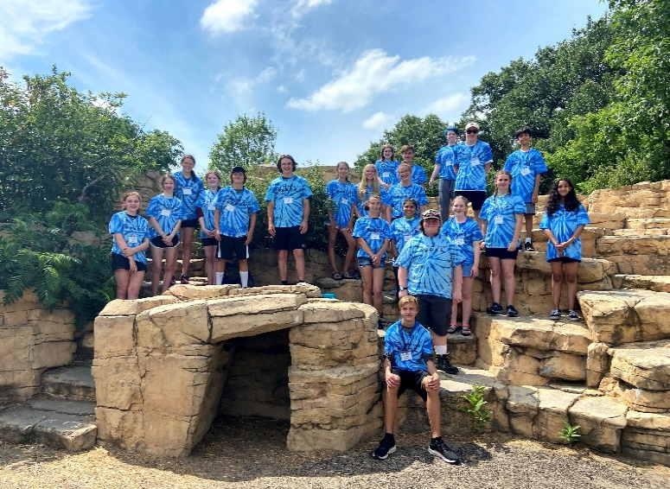

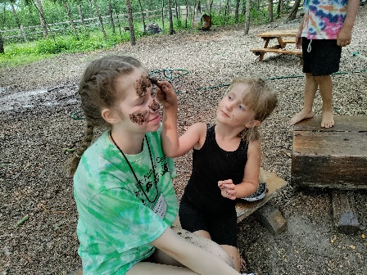

• As long as you work hard, remain positive and responsible, and meet the general requirements, you hold a position as a Tamarack JAN for as many summers as you choose until you are 18 years old!

• Get a Tamarack Summer Camp t-shirt and water bottle each summer.

• Build leadership skills; gain valuable, fun, hands-on experience working with children and nature.

• Volunteer time may be eligible for service learning credits and is always great for resume building.

• An exclusive JAN Campfire Celebration at the end of the season.

**What are the benefits of being a JAN?**

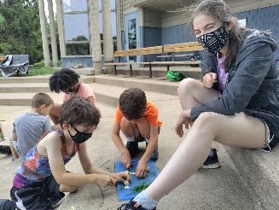

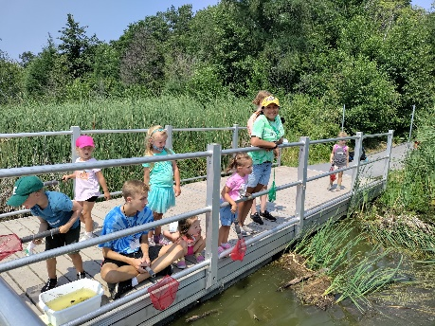

**How do I apply to be a JAN?**

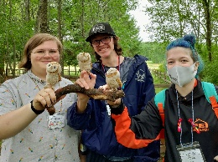

* Complete the enclosed application and availability/ preferences document and return them to Tamarack by **Saturday, April 22nd** You will receive an e-mail notifying you that your information was received.
* Returning JANs don’t need to re-interview.
* Once new JANs are interviewed and selected everyone will be placed on camps according to your availability, skills, and interests. Final camp assignments will be sent to you by the June 1st (earlier if possible).

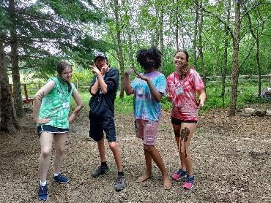

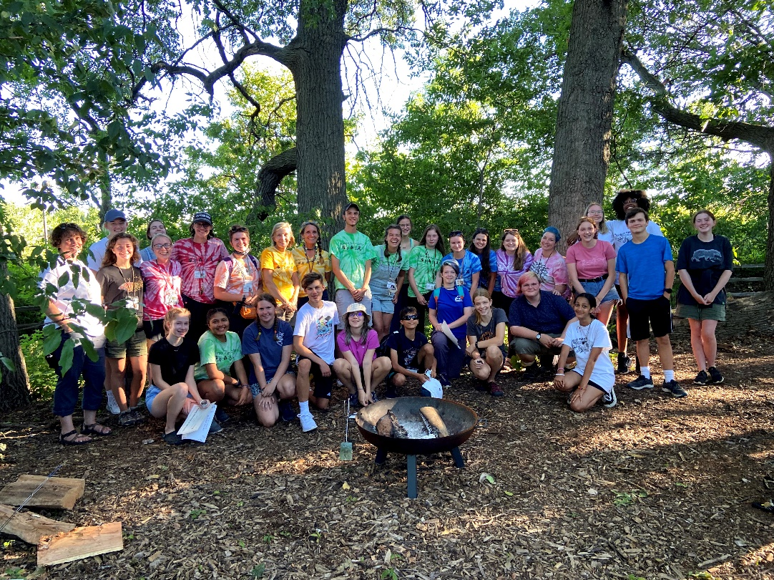

**Returning**

**Junior Assistant Naturalists**

**JAN Checklist:**

❑ Complete the enclosed application materials and return them to Tamarack by the deadline: **Saturday, April 22nd**

 JAN Volunteer Application

 Availability & Preferences

q JANs selected and schedules assigned: **June 1s 2022.**

q Mandatory training dates:

* **Wednesday, June 15th 9:30 am to 12:30 pm**
* **Thursday, June 16th 10:00 am to 3:00 pm (All camp staff training)**

q The end-of-summer JAN Campfire Celebration: **Thursday, August 11th**

5287 Otter Lake Road, White Bear Township, MN 55110

Phone: 651-266-0360   
Email: tamarack@co.ramsey.mn.us **www.TamarackNatureCenter.org**



**2022 Returning Junior Assistant Naturalist**

**VOLUNTEER APPLICATION**



5287 Otter Lake Road, White Bear Township, MN 55110

Phone: (651) 266-0360

Email: tamarack@co.ramsey.mn.us **www.TamarackNatureCenter.org**

|  |  |
| --- | --- |
| First Name: | Click or tap here to enter text. |
| Last Name: | Click or tap here to enter text. |
| Date of Birth: | Click or tap to enter a date. |
| Address: | Click or tap here to enter text. |
| City: | Click or tap here to enter text. |
| Zip: | Click or tap here to enter text. |
| Primary Phone: | Click or tap here to enter text. |
| Cell Phone: | Click or tap here to enter text. |
| Grade Level: | Choose an item. |
| School: | Click or tap here to enter text. |
| Adult T-Shirt Size: | Choose an item. |

***We communicate with our volunteers extensively through e-mail. Please list the e-mail address you want us to use when communicating with you throughout this application process and throughout the summer. If you need us to send communications to both parent and student e-mail addresses, please list both.***

|  |  |  |  |
| --- | --- | --- | --- |
| Primary Email Address: | Click or tap here to enter text. | belongs to: | Click or tap here to enter text. |
| Additional Email Address: | Click or tap here to enter text. | belongs to: | Click or tap here to enter text. |
| Additional Email Address: | Click or tap here to enter text. | belongs to: | Click or tap here to enter text. |

**Please tell us what interests you. Check all that apply:**

Water Recreation

Mud and Mayhem

 Outdoor Survival Skills

Storytelling

Animal Care

 Character Role Play

History

Gardening and Plants

 Cooking

Birds

Insects

Hiking

Arts & Crafts

 Fossils & Geology

Exploration & Adventure

Experiments

Birds

Other _______



**2022 Returning Junior Assistant Naturalist**

**AVAILABILITY & PREFERENCES**



5287 Otter Lake Road, White Bear Township, MN 55110

Phone: (651) 266-0360  
Email: tamarack@co.ramsey.mn.us **www.TamarackNatureCenter.org**

**Name of JAN:** Click or tap here to enter text.

**How Many Weeks would you like to volunteer as a Junior Assistant Naturalist this summ**er? Choose an item.

|  |  |  |  |  |
| --- | --- | --- | --- | --- |
| **Camp Week** | **Dates:**  **8:30 am-4:30 pm,**  **Mon- Thurs** | **Please Check all the weeks you are available:** | **Before Care:**  **7:30 – 9:00 am**  **Mon-Thurs** | **After Care:**  **4:00- 5:30 pm**  **Mon- Thurs** |
| **Week 1** | June 21-23 (3 Days/ Tues-Thurs) |  |  |  |
| **Week 2** | June 27 – 30 |  |  |  |
| **Week 3** | July 11 - 14 |  |  |  |
| **Week 4** | July 18 - 21 |  |  |  |
| **Week 5** | July 25 - 28 |  |  |  |
| **Week 6** | August 1 - 4 |  |  |  |
| **Week 7** | August 8 - 11 |  |  |  |
| **Week 8** | August 15 - 18 |  |  |  |

**\*\*No Camp the week of July 4th\*\***

**Before and aftercare is providing extended care for campers before camp from 7:30 to 9 am and after camp from 4 to 5:30 pm. If you can help supervise campers during this time, please check the box in the weeks you can help.**

**Sometimes the schedule requires half day shifts. If you are scheduled for a half-day preschool camp in the morning or afternoon, will you have transportation to or from Tamarack at lunchtime?**

Choose an item.

**Review the enclosed document called “Connecting Children with Nature” to see what you can expect from each age of campers. Then tell us the top 3 age groups you would like to work with this summer. We will consider your preferences when scheduling but will also try to give you a well-rounded experience.**

**#1 Choice:** Choose an item.

**#2 Choice:** Choose an item.

**#3 Choice:** Choose an item.

Check this box if you are comfortable working with any age group!

**Please provide any other information about your summer schedule that you think would be helpful to us.**

Click or tap here to enter text.



**2022 Returning Junior Assistant Naturalists**

**CONNECTING CHILDREN WITH NATURE**

|  |  |
| --- | --- |
| **Sprouts (3 years old)** | |
| **Developmental Characteristics:**  Need opportunities to explore  Beginning to develop a sense of independence  Enjoy dramatic play with others  Learning how to share  Enjoy sensory learning and play  Need clear and consistent rules and consequences  Can make simple choices between two things  Practicing their words and expression of feelings | **Age-Appropriate Nature Activities:**  Pick flowers and berries  Feel fuzzy leaves  Play Hide & Seek in the bushes  Balance on a log  Run through a field  Splash in puddles  Sing silly songs  Play I Spy |
| **Critters (4 & 5 years old)** | |
| **Developmental Characteristics:**  Very talkative and enjoy discussion  Ask a lot of “how” and “why” questions  Developing classification skills and reasoning  Working on fine motor skills  Enjoy a hands-on learning approach | **Age-Appropriate Nature Activities:**  Listen to and discuss a story  Make a tree bark boat and sail it  Blow dandelion seeds  Go for a blindfold walk  Start a rock collection |
| **Discoverers (1st & 2nd grade)** | |
| **Developmental Characteristics:**  Enjoy doing and exploring  Wrapped up in self  Incorporate senses into activities  Have a short attention span  Lots of energy  Can focus on teamwork rather than competition  Need specific, clear instructions  Beginning to reason logically  Enjoy collecting, organizing, and sorting | **Age-Appropriate Nature Activities:**  Dig for worms  Hunt for wild edibles  Run through sprinklers  Play organized games  Go pond dipping  Gaze at the clouds  Read a book  Paint with watercolors  Make leaf rubbings |

|  |  |
| --- | --- |
| **Explorers (3rd & 4th grade)** | |
| **Developmental Characteristics:**  Need recognition & praise for good work  Have rapidly changing interests  Enjoy activities that use the whole body  Easily motivated  Beginning to define self through accomplishments  Enjoy imaginative play  Learning to plan ahead and evaluate  Starting to consider the perspective of others | **Age-Appropriate Nature Activities:**  Make walking sticks and use them  Go on a nature scavenger hunt  Go pond dipping  Have a cookout  Skip stones at the lake  Go canoeing  Play organized games  Make paper |
| **Trekkers (5th & 6th grade)** | |
| **Developmental Characteristics:**  Beginning to desire independence  Very concerned with fairness  Good listeners  Like rules and logic  Prefer new tasks and experiences over reflection  Developing a more mature sense of right and wrong  May shrug off responsibility  Difficulty making decisions  Developing ideals and selecting role models  Good with teamwork, but can also be competitive | **Age-Appropriate Nature Activities:**  Build a fort with friends  Go canoeing  Write a poem  Build a fire  Design a tree house  Paint with watercolors  Search for wild edibles and make a salad  Play team building games  Learn about animal tracks  Have a relay race |
| **Adventurers (7th & 8th grade)** | |
| **Developmental Characteristics:**  Capable of abstract thought  Capable of longer, more active adventures  Enjoy interacting with peers  Enjoy solving real-life problems  Capable of independent, critical ideas | **Age-Appropriate Nature Activities:**  Design and construct a garden  Use GPS units to navigate  Debate an environmental issue with peers  Go on a canoeing adventure  Create a nature challenge for younger kids |