Txheej Xwm Pab Cov Neeg Nyob Hauv Minnesota Txhaj Tshuaj

Tsev Txhaj Tshuaj COVID-19 Dawb Xwb
Muaj sijhawm teem rau:
05/10/2022 – 06/30/2022

Cov chaw thiab lub sijhawm:
West St. Paul Clinic – Tuesdays, 5:30 txog 7:30p.m.
Brooklyn Park Clinic – Thursdays, 5:30 txog 7:30 p.m.
Minneapolis Clinic – sib pauv Saturdays, 9 a.m. txog 3 p.m.
St. Paul Clinic – sib pauv Saturdays, 9 a.m. txog 3 p.m.

Hom tshuaj tiv thaiv: Pfizer

Pfizer thawj koob thiab koob thib ob: Yuav tsum muaj tsib xyoo lossis laus dua (5+)
Pfizer booster koob tshuaj: Yuav tsum muaj kaum ob xyoo lossis laus dua (12+)
* Cov menyuam uas muaj hnub nyoog 12 mus rau 15 xyoos, lawv niam txiv yuav tsum tso cai thiab nyob ntawd nrog lawv tus menyuam thaum txhaj tshuaj.

Teem ib lub sijhawm mus txhaj tshuaj:
- Muaj ntau cov thawj koob tshuaj rau hnub _/_/2022. Siv tus ntawv txuas no (link) mus teem ib lub sijhawm rau koj mus txhaj tshuaj. https://my.primary.health/r/childrens-mn?registration_type=default
- Lossis siv tus QR code hauv qab no:

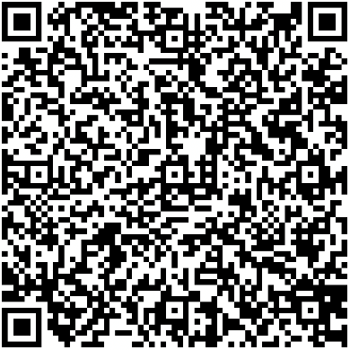

Yuav npaj dabtsi thiaj li teem tau sijhawm:
- Yuav npaj qhia koj lub npe, xeem, hnub yug, thiab chaw nyob.
- Yog tias koj muaj, xav kom tso koj tus xov tooj ntawm tes thiab tus email.
- Yog koj teem tsis tau sij hawm ua ntej, cia li tuaj xwb los tau.

Yuav nqa dabtsi tuaj rau hnub koj teem caij:
- Koj yuav tsum looj daim ntaub npog qhov ncauj thiab sib nrug deb ntawm lwm tus raws li txoj cai.
- Yuav rov nug dua koj npe, xeem, hnub yug, thiab chaw nyob.
- Yuav TSIS nug txog koj daim ID.
- Yuav TSIS nug txog koj li ntawv pov hwm kev kho mob.
- Yeej muaj cov tibneeg pab txhais lus thiab txhais lus piav tes American Sign Language (ASL).
- Muaj cov tibneeg pab rau ADA thiab.

Tsheb pab thauj:
- Npaj sijhawm yam uas siv Metro Transit Trip Planner: Trip Planner - Metro Transit (teem sijhawm).
- Cov neeg ua tswv cuab hauv Metro Mobility Customers uas muaj npe nyob hauv lawm hu teem sijhawm tau rau cov npav tuaj tos lawv yog 651-602-1111 (TTY 651-221-9886).

Minnesota Department of Health | health.mn.gov | 651-201-5000
625 Robert Street North PO Box 64975, St. Paul, MN 55164-0975

