Barnaamijka Talaalka Bulshada ee Minnesota

Tallalka COVID-19 oo lacag la'aan ah
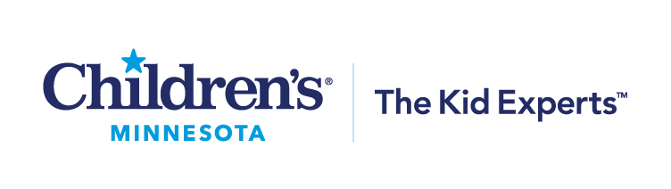
Waqtiga la heli karo ballanta tallaalka:
05/10/2022 – 06/30/2022

Goobaha iyo waqtiyada tallaalka:
West St. Paul Clinic – Tuesdays, 5:30 to 7:30 p.m.
Brooklyn Park Clinic – Thursdays, 5:30 to 7:30 p.m.
Minneapolis Clinic – rotating Saturdays, 9 a.m. to 3 p.m.
St. Paul Clinic – rotating Saturdays, 9 a.m. to 3 p.m.

Nooca tallaalka: Pfizer

Pfizer qiyaasta koowaad iyo labaad: Waa inaad tahay shan jir ama ka weyn Qiyaasta xoojinta Pfizer: Waa inaad jirtaa lix iyo toban sano ama ka weyn

*Waalidiintu waa inay oggolaansho bixiyaan dhammaan carrurta aan qaangaarin. Waxaa laga rabaa waalidka in uu joogo goobta tallaalka marka caruurta da'doodu u dhaxayso 5-15 jir la tallaalayo.

Sida aad iskugu diwaangelin lahayd ballanta:
- Hadda ballan waxaa loo qabsan karaa qaybta kowaad ee tallaalka tariikhda kor ku qoran. Si aad u samaysato ballan, isticmaal boggan internka : https://my.primary.health/r/childrens-mn?registration_type=default
- Sawir ama Iskaan ka qaad koodhka hoos ku yaala

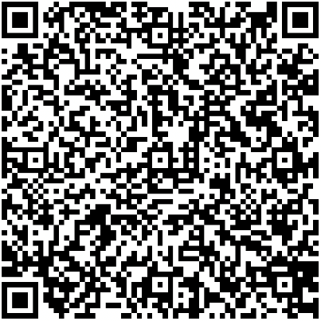

Waxa aad u baahan tahay si aad balan u qabsato:
- Waxaad u baahan tahay oo kali ah inaad bixiso magacaaga koowaad, magaca awoowga, taariikhda dhalashada iyo cinwaanka guriga.
- Waxaa lagugu dhiirigelinayaa inaad bixiso taleefon lambarkaaga iyo cinwaankaaga iimayl, haddii aad leedahay.
- Haddii aadan horay ballan u qabsan, waa lagu qaabilayaa haddii aad imaatid.

Waxad u baahan tahay maalinta ballantaada:
- Waxaa lagaaga baahan yahay inaad Maaskaro xirato oo aad u hoggaansato shuruudaha kala fogaanshaha dadka.
- Waxaad u baahan tahay inaad xaqiijiso magacaaga koowaad, magaca awoowga, taariikhda dhalashada iyo cinwaanka guriga.
- Uma BAAHNID inaad sharci la timaado.
- Uma BAAHNID ceymiska caafimaad.
- Turjumaada luuqadaha iyo American Sign Language (ASL) (Luuqadda Dhagoolka ee Mareykanka) ayaa goobta laga heli doonaa.
- Fududeynta ADA (Sharciga Naafada Mareykanka) ayaa goobta laga heli doonaa.

Gaadiidka dadweynaha:
- Qorsheeyaha Socodka Gaadiidka Basaska: Qorsheeyaha Socodka – Gaadiidka Basaska (Trip Planner - Metro Transit).
- Macaamiisha Metro Mobility (Gaadiid Raaca La Wadaago) ee sharciyeysan ayaa wacan kara bixiyeyaasha gaadiid raaca si ay uga qabsadaan balanta safaradooda 651-602-1111 (TTY 651-221-9886).

Minnesota Department of Health| health.mn.gov | 651-201-5000 625 Robert Street North PO Box 64975, St. Paul, MN 55164-0975

