Neighbors and Deputies working together for safer communities

Block Captain News – March 2017
Next Meeting Tuesday, May 2 – 6:30 pm
In this issue:
Security & Safety tips from February meeting
Bike safety reminders
Distracted driving enforcement ahead
Coffee with a Cop, Shoreview 3/31/17
2017 Block Captain Meeting Schedule
Ramsey County Public Works Building - Marsden Room
1425 Paul Kirkwold Drive, Arden Hills MN 55112
Near intersection of Highway 96 and Hamline

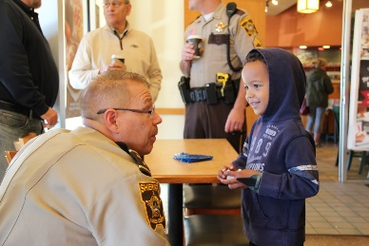
Coffee with a Cop – Friday, March 31
Continuing the community engagement experience of Night to Unite and Hot Dog with a Deputy, the Sheriff’s Office Public Safety Services Division will be holding a Coffee with a Cop event in March.
The goal of a Coffee with a Cop event is to bring neighbors and deputies together in an informal, neutral space to chat. No speeches or agenda – just conversation.
The next Coffee with a Cop is scheduled for Friday, March 31 from 8:30-10 am at the Starbucks @ Kowalski’s, 441 County Highway 96, Shoreview (at Hodgson Road)

Home Security & Safety considerations
Safety and security education is the subject matter focus of Block Captain meetings in 2017. The February topic was Home Security and Safety. In May the focus will be on personal safety, and the November meeting will explore internet and cyber safety.
Deputy Tim Schwab, Crime Prevention Unit, covered the following topic areas at the February meeting:
- Preventive maintenance tips for the home
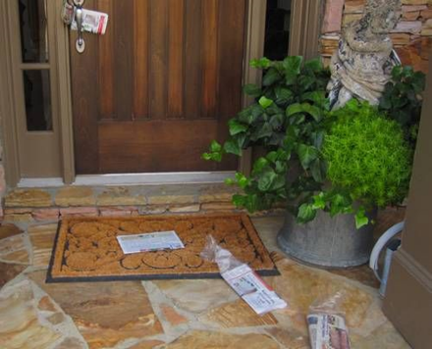
- Personal/Family safety tips while at home
Anyone home?
- Options to consider while away
- Interaction with neighbors
- Interaction with Law Enforcement- When to call 911 & what information to provide
- Wireless cameras and technology
Tips to make your home a more difficult target for burglars, thieves and other problem visitors included locks, lighting, landscaping, securing trailers, and tips about not ‘advertising’ absences or stuff to steal.
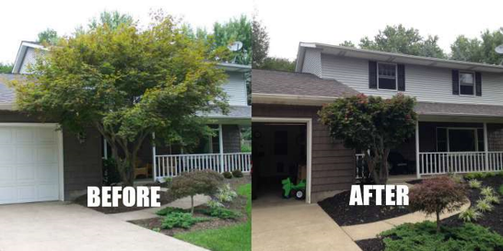
Safety and home security can be as easy as keeping entry doors locked, even when at home, keeping garage doors closed, being aware of suspicious vehicles and foot traffic by recognizing what is ‘normal’ for your area. At night be certain vehicles in the driveway are locked and have valuable removed, removing garage door openers from vehicles, have keys on the bedside at night, and confirming doors are locked before going to bed.
Interaction with neighbors includes sharing your knowledge as a block captain, being a resource, sharing contact information such as phone numbers and email, knowing emergency contact information and staying current on crime trends.
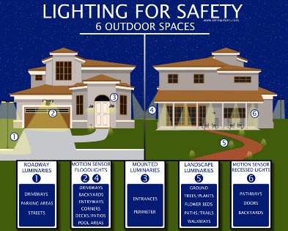
The main message on interaction with law enforcement is that deputies want to hear from you. The time to call 911 is when something is happening, not a day a two later. Callers can remain anonymous or request return contact be made by phone. The 911 dispatcher will help the process by gathering critical information such as address, actual location, and major cross streets. Observation of the event should be shared as clearly and precisely as possible. Vehicle descriptions that include the license number, state of issue, type such as truck, SUV or car, color of vehicle, any distinctive items such as body damage, loud exhaust, stickers or lights. The direction of travel and the number of occupants of a vehicle also are details that can help responding deputies. The physical description of suspects is also very important including race, sex, height, weight, clothing description and whether or not a weapon was observed. When requesting contact by deputies let them make contact with you, stay in your home, and do not take action unless absolutely necessary.
A review of various home security technology products was also made by participants in the meeting.
Home security and safety is a matter of being aware of your surroundings, paying attention, and planning ahead in the event of an incident or emergency.
Personal Safety will be the topic of the next Block Captain Meeting, scheduled for Tuesday, May 2, 2017. The meeting will be held at the Marsden Room, 1425 Paul Kirkwold Drive, Arden Hills, starting at 6:30 pm.
MAIL THEFT REMINDER
Deputies are continuing to investigate incidents of fraud and forgery that have traced back to outgoing mail stolen from roadside mailboxes. Thieves have continued to drive through neighborhoods looking for red flags and the checks waiting inside. They then ‘wash’ those checks, write in different amounts to different payees, and proceed to find ways to cash them. In a few cases quick thinking bank tellers have foiled the thieves, observant citizens have called 911 when they see the theft happen, and unfortunately, in other cases our neighbors have learned they’ve been victimized when they get their bank statement.
Remind your neighbors, family, friends, and co-workers to be aware of the realities of mail theft. Prevention tips include using a gel pen when writing checks to make them more difficult to wash, use electronic payments when possible, and deposit outgoing mail securely into USPS drop boxes.
Signs of Spring - Bikes and Pedestrians
Spring in Minnesota finds more people out and about, which means attention needs to be paid to bike and pedestrian safety. Bicycles are sharing the road with motor vehicles more often, which means it is important to remember bicyclists and motorists are equally responsible for bicycle safety. The number-one factor contributing to bicycle-vehicle collisions is failure to yield the right-of-way — by bicyclists and drivers alike.
About one-half of all bicycle-vehicle collisions are due to a variety of bicyclist behaviors, such as disregarding a traffic sign or signal. The other half are caused by vehicle driver behaviors, such as inattention and distraction.
Bicycling Rules of the Road and Safety Tips
- Bicyclists may ride on all Minnesota roads, except where restricted.
- Bicyclists should ride on the road, and must ride in the same direction as traffic.
- Motorists must at all times maintain a three-foot clearance when passing a bicyclist.
- Bicyclists must obey all traffic control signs and signals, just as motorists.
- Bicyclists must signal their turns and should ride in a predictable manner.
- Bicyclists must use a headlight and rear reflectors when it's dark. To increase visibility, add a rear flashing light.
- Drivers must drive at safe speeds and be attentive — look for bicyclists, check blind spots.
- Drivers should use caution and look twice for riders when turning.
- Drivers should use caution when opening door upon parking on side of road.
The Sheriff’s Office will be conducting a Bike Rodeo on Thursday, June 15, 2017, at Island Lake County Park, 3611 North Victoria Street, Shoreview. The event will run from 8:00 am to 11:00 am, and is open to all Ramsey County residents. This Bike Rodeo will have four components, including equipment check, safety instruction, rules of the road, and an obstacle skills course. It will take about 45-60 minutes to complete all the training, and sessions will start on the hour. Bike rodeos are geared toward children; however adult riders are welcome to participate in the training too. Advance registration is appreciated, and can be done online at https://www.surveymonkey.com/r/Bikerodeo2017, or by calling 651-266-7332.
Pedestrian Safety Is Everyone's Responsibility
Failure to yield the right-of-way and driver inattention/distraction are the main contributing factors in pedestrian crashes.
Watching out for bicyclists, pedestrians, and vehicles when we are out an about in our neighborhoods and city streets throughout the year is always the right thing to do. Enjoy the weather and stay safe.
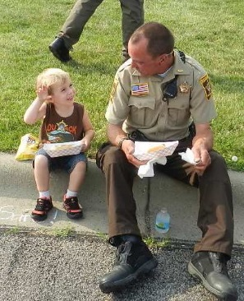
Hot Dog with a Deputy 2017
Hot Dog with a Deputy returns this summer to connect the community and the Sheriff’s Office. On Tuesday evenings, beginning in June, bring the family out to the park for free hot dogs, equipment demonstrations, and conversation with deputies. See the calendar on page five of this newsletter for dates and places!
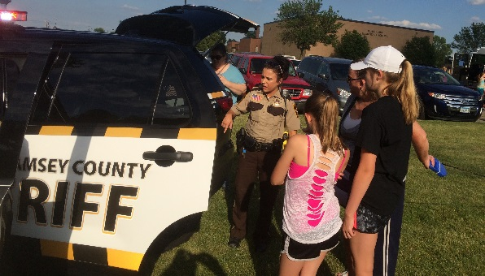
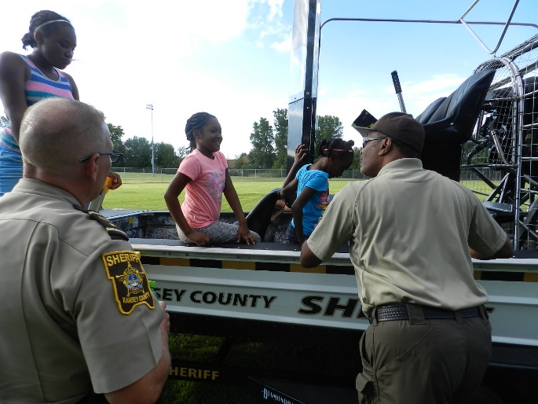

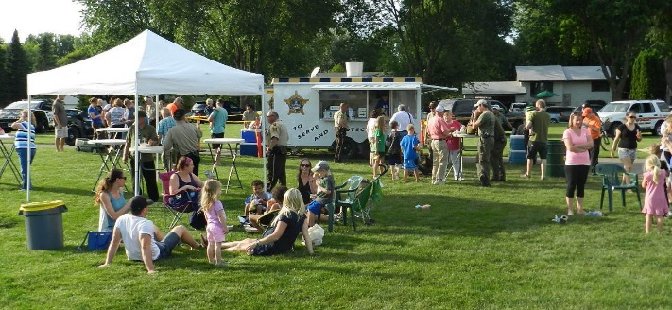

Distracted Driving Enforcement: extra patrol efforts scheduled for April 10-April 23
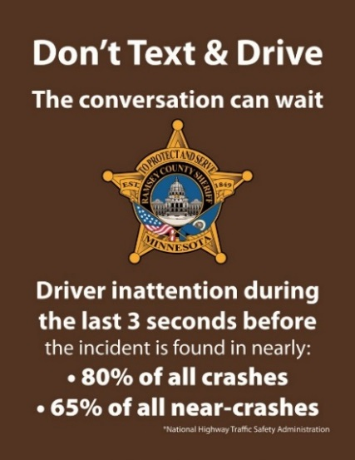
Distracted driving has emerged as one of the key safety issues in the United States. The Minnesota Toward Zero Deaths (TZD) is the state’s cornerstone traffic safety program, employing an interdisciplinary approach to reducing traffic crashes, injuries, and deaths on Minnesota roads. The Sheriff’s Office, as a partner in the Ramsey County Traffic Safety Initiative (RCTSI), works with TZD on enforcement and education of traffic laws toward the goal of zero deaths on Minnesota roads.
During the year the nine RCTSI police agencies work together to focus attention on problem traffic safety behaviors such as Impaired Driving, Seat Belts, Child Safety Restraints, Speeding, and Distracted Driving.
Look for enhanced enforcement of Distracted Driving laws from April 10 to April 23 statewide, when all TZD agencies take part in this twice a year focused effort.
The 2015 Minnesota Distracted Driving Survey (pdf weblink), found that 29.13 percent of drivers were distracted. The top four distraction were: rear passenger interaction, cell phone handling, cell phone conversation, and eating.
Other notable findings include:
- Driver distraction rate for males is higher, at 30.15 percent vs. females at 27.59 percent.
- The 16–29 driver age group has the highest distraction rate, at 35.46 percent.
- Among vehicle types, vans/minivan drivers have the highest distraction rate, at 37.64 percent.
Be part of the solution – don’t drive distracted.

Immigration issues and the Ramsey County Sheriff’s Office
The national political scene has focused attention on the issues of immigration. One component of this discussion has been how local law enforcement is impacted by this issue. In response to questions from the public on how the Ramsey County Sheriff’s Office is impacted by the national immigration issue discussion, Sheriff Jack Serier issued the following on March 3, 2017:
- The primary role of law enforcement is victim advocacy, keeping the peace, and enforcing state criminal law. As such, we advocate for all victims regardless of their citizenship or immigration status. We are also an agency that regularly approves U-Visas to victims and witnesses of crimes who have immigration status issues. It is a way that we can help in the effort to protect victims who may not have proper status in this country.
- Our Sheriff’s Office does not ask for proof of citizenship or immigration status. We provide service to all with whom we come into contact and will continue to do so.
- We arrest people for state criminal code violations, no matter their citizenship or immigration status. Our focus is on holding all people accountable who violate the law and thereby create victims.
- Our Office only holds people in custody for state criminal violations and orders issued by judges via the court. We do not engage in holds of people for civil immigration issues.
Sheriff Serier will be holding a community meeting on this topic in mid-April. Details will be announced on social media, Twitter and Facebook, and via a news release when finalized.

Crime Prevention Deputy Tim Schwab to be promoted to Sergeant
On April 5 Deputy Tim Schwab will be promoted to Sergeant at the Sheriff’s Office Badge Pinning and Promotion Ceremony at Landmark Center in Saint Paul. Tim, who has served as the Crime Prevention Deputy since December of 2015, will be the overnight patrol supervisor for the contract communities. His new schedule will have him available to attend the May Block Captain meeting to introduce his replacement (who has not been selected at the time of this newsletter) and conduct the Personal Safety training session. Tim has been a valued member of Community Support Services during his tenure, where his work ethic and leadership skills have been appreciated. Those attending the May meeting will be able to hear from a front line supervisor on what is happening on the streets of our communities while most residents are asleep. Another reason to attend!

Mark your calendars for 2017 events:
Friday, March 31 – 8:30-10:00 am – Coffee with a Cop, Kowalski’s Starbucks, Shoreview
Tuesday, May 2 – 6:30 pm – Captains Meeting, Marsden Room, 1425 Paul Kirkwold Drive, Arden Hills
Tuesday, June 6 – 5:00-7:00 pm – Hot Dog with a Deputy – Bobby Theisen Park, Shoreview
Tuesday, June 13 – 5:00-7:00 pm – Hot Dog with a Deputy – Polar Lakes Park, White Bear Township
Thursday, June 15 – 8:00-11:00 am – Bike Rodeo – Island Lake County Park, Shoreview
Tuesday, June 20 – 5:00-7:00 pm – Hot Dog with a Deputy – Berwood Park, Vadnais Heights
Tuesday, June 27 – 5:00-7:00 pm – Hot Dog with a Deputy – Pioneer Park, Little Canada
Tuesday, July 11 – 5:00-7:00 pm – Hot Dog with a Deputy – Tony Schmidt Park, Arden Hills
Wednesday, July 12 – 5:00-7:00 pm – Hot Dog with a Deputy – Commons Pavilion, Shoreview
Tuesday, July 18 – 5:00-7:00 pm – Hot Dog with a Deputy – West Rec Center, North Oaks
Tbd, July 25 or 26 – 6:00 pm – Night to Unite Hosts / Captains Appreciation Dinner
Shoreview Community Center, Community Room
4580 Victoria Street North
Tuesday, August 1 – Night to Unite events in neighborhoods throughout the community
Tuesday, November 14 – 6:30 pm – Captains Meeting, 1425 Paul Kirkwold Drive, Arden Hills
Night to Unite 2017:
Mark your calendar for Tuesday, August 1, 2017 for Night to Unite. Seems like the first Tuesday in August is a long way off as the Crime Prevention Unit begins planning for this year. Ideas are welcomed for materials to have for distribution at the neighborhood gatherings. Send us an email to help get the party started!
Thank you for working for safer neighborhoods!

Deputy Tim Schwab Randy Gustafson
Crime Prevention Specialist Public Communications Coordinator
651-266-7339 651-266-7315
email address: CrimePrevention@co.ramsey.mn.us website: www.RamseyCountySheriff.us
Remember – when you See Something, Say Something, Call 9-1-1

