Overview

This guide will assist February 2016 Coaching Circle leaders in facilitating a discussion regarding the application of Intermediate Coaching Trainings into staff’s every day work. Those leading the circle will facilitate discussions and next steps regarding the “Reflect and Plan” activities that were completed throughout the Intermediate Coaching Training and the “Action Plan” which was completed at the end of the training.

Facilitators will work towards the following objectives:
- Refresh staff memory of content from the Intermediate Coaching Trainings.
- Encourage commitment towards implementing coaching in a manageable, employment specific way through the development of SMART goals.
- Encourage staff to own their professional development around coaching techniques.

BEFORE THE CIRCLE BEGINS:
Materials: Ensure all required materials are present at the circle
- Intermediate Coaching Trainer Guide (required)  - Intermediate Coaching Training Staff Resource Guide (required) |  | - Colored Markers (optional)
- Projector (required) |  | - Flip Charts (optional)
- Power Point Presentation (required)
Room Set-up: Circle of chairs or chairs situated around a large table. How many minutes total for this circle??
FEBRUARY COACHING CIRCLE
Slide # | Description
Cover Slide
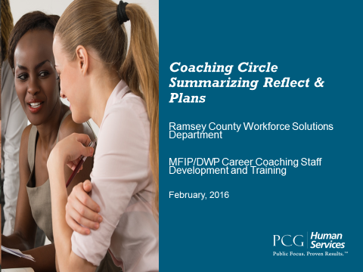 | Introductions:  The facilitator of the coaching circle should start the group off with a game, activity or introduction to help break the ice and build rapport among the group.  The facilitator has freedom to do what is meaningful and natural for them.

Slide 2 | Lesson Overview
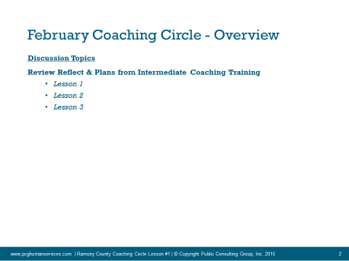 | The facilitator should give a preview of what will be discussed today.  Emphasize that training only works when we take the most useful concepts and apply them, in a meaningful way, to our particular day to day work.  Emphasize this is time to learn from each other, discuss challenges or questions remaining from the training, and create our own personal SMART goals and next steps around coaching.
Review of Reflect and Plans
Slide 4 |  | Review Reflect & Plan Topics from Lesson #1
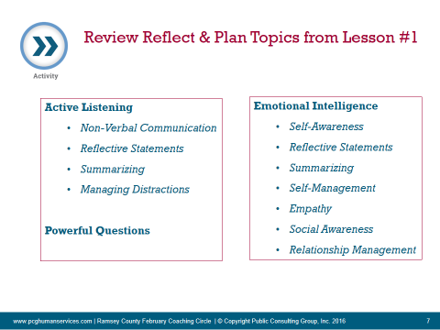 |  | - These are the topics that were covered in Lesson/Week #1 of the Intermediate Coaching Training.  - Turn to page 42 in your “Intermediate Coaching Training Staff Resource Guide”. During lesson #1 we started to write our strengths and growth areas in each of these areas.  - Review or complete this section fully. Use your “Intermediate Coaching Training Staff Resource Guide” to review the concepts and help you complete this section. Go back to other Reflect and Plans throughout the lesson to gain more insight.  - Facilitator will lead the group in a discussion. Questions to get the group started could include:  - What is one of your biggest strengths and growth areas from this lesson?  - What other resources do you want to access in order to learn more (for example, a more robust EI quiz)?  - Share some of your lessons learned from the past about these growth areas. (For example, do you use private rooms for interviews so that you can manage distractions or build better rapport?  - Have you found that reflective statements work best when paired with a lot of empathy and reflection of emotion, not just a reflection of words?  The facilitator should use the “Intermediate Coaching Trainer Guide” to reference or review any concepts that require clarification or deeper discussion.  The facilitator should keep the group positive, safe and productive in their discussion around coaching.
Slide 5 |  | Review Reflect & Plan Topics from Lesson #2
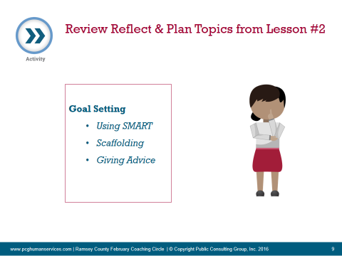 |  | - Repeat the above sequence, this time for Lesson/Week #2
Slide 6 |  | Review Reflect & Plan Topics from Lesson #3
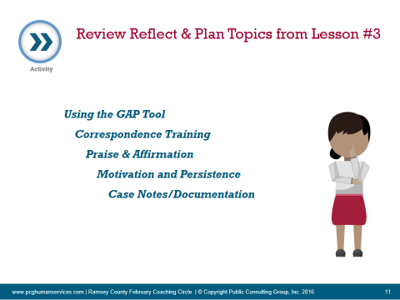 |  | - Repeat the above sequence, this time for Lesson/Week #3

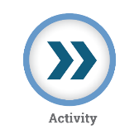 | Summarizing “Reflect and Plans” - Coaching for Success
LESSON ONE
Domains | Strengths | Improvements
 | Describe Your Personal Strengths in each Dimension | What Would You Like To Change/Improve?
Active Listening
Non-Verbal Communication

Reflective Statements

Summarizing

Managing Distractions

Powerful Questions
Powerful Questions

Emotional Intelligence
Self-Awareness

Self –Management

Empathy

Social Awareness

Relationship Management

LESSON TWO
Domains | Strengths | Improvements
 | Describe Your Personal Strengths in each Dimension | What Would You Like To Change/Improve?
Goal Setting
Using SMART

Scaffolding

Determining when to give advice

LESSON THREE
Domains | Strengths | Improvements
 | Describe Your Personal Strengths in each Dimension | What Would You Like To Change/Improve?
Use of GAP Tool as coaching tool

Correspondence Training

Praise/Affirmation

Motivation and Persistence

Case Notes

