Overview

This guide will assist Coaching Circle leaders in facilitating a discussion regarding the application of concepts and techniques learned in Introductory and Intermediate Coaching Trainings. The Coaching Circle Lesson #2 will focus on incorporating the challenge areas staff identified on their individual Reflect & Plans in Coaching Circle Lesson #1 into an Action Plan.

Facilitators will work towards the following objectives:
- Refresh staff memory of content from the Intermediate Coaching Trainings, specifically Action Planning and Goal Setting.
- Encourage commitment towards implementing coaching in a manageable, job specific way through the development of SMART goals.
- Encourage staff to own their professional development around coaching techniques.

BEFORE THE CIRCLE BEGINS:
Materials: Ensure all required materials are present at the circle
- Intermediate Coaching Trainer Guide (required)  - Intermediate Coaching Training Staff Resource Guide (required) |  | - Colored Markers (optional)
- Projector (required) |  | - Flip Charts (optional)
- Power Point Presentation (required)
Room Set-up: Circle of chairs or chairs situated around a large table.
MARCH COACHING CIRCLE
Slide # | Description
Slide #1 - Cover Slide
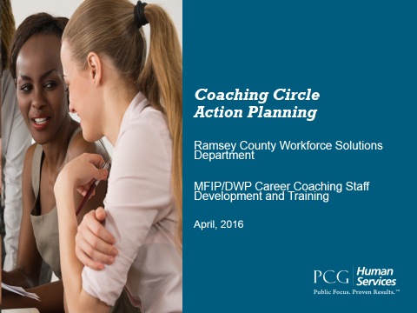 | Introductions:  The facilitator of the coaching circle should start the group off with a game, activity or introduction to help break the ice and build rapport among the group.  The facilitator has freedom to do what is meaningful and natural for them.

Slide 2 | Lesson Overview
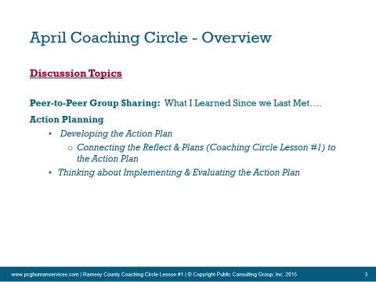 | - The facilitator should provide a preview of what will be discussed today.  - Emphasize that training only works when we take the most useful concepts and apply them, in a meaningful way, to our particular day to day work.  - Emphasize this is time to learn from each other, discuss challenges or questions remaining from the training, and create our own personal SMART goals and next steps around coaching.
Slide 3 |  | Peer-to-Peer Group Discussion
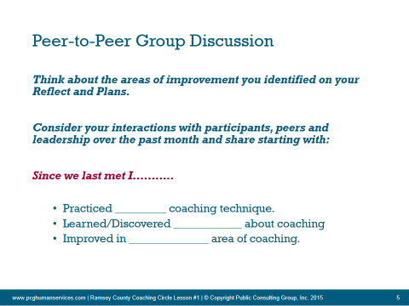 |  | - The facilitator will break the circle into smaller sizes (3-5 people) for discussion.  - During this peer-to-peer discussion, conversation should remain focused on the participants experience implemented coaching in the prior month.  - Facilitator should bring group back together and address any questions or discuss key themes. Multiple teaching tools can be used to bring the group together and more experienced facilitators should feel free to use white boards, sticky notes, or other hands on and visual tools to facilitate discussion. Newer facilitators can ask each group to volunteer to report on key points discussed.
Action Planning
Slide 5 - 6 |  | Developing the Action Plan
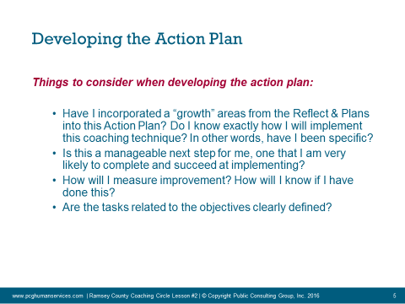  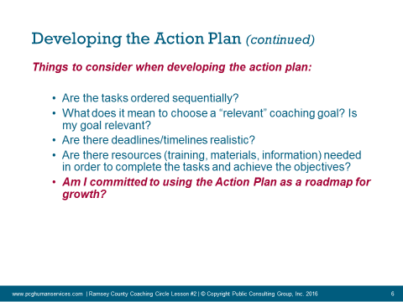 |  | - Facilitator should introduce the section. “Just like our clients need SMART goals in order to help them make change in their lives, we also are more likely to implement change if we have SMART goals for professional development.” and progress.”  - Facilitator should allow the group a few minutes to review and re-familiarize themselves with their “Summarizing Reflect and Plan” document that was finalized in Coaching Circle Lesson #1. Explain that this will be used and incorporated into their Action Plan. Have staff choose one area of growth that they would like to turn into a SMART goal. This will be the basis for the Action Plan. (Some staff may have already filled out an Action Plan. If so have them either use the one they have already filled out or to create a second one.)  - Remind the group that without a sincere commitment to practicing and improving, all of their efforts to become better at coaching will have no impact. Bring this back to coaching too. State “Just like our participants need to own their own goals and progress, this will only work if you are genuinely committed to the process. When developing SMART goals for Coaching, pick an aspect of coaching that speaks to you, one that you are genuinely committed to.”  - Before diving into writing the goal action plan, ask group to turn to the end of their “Intermediate Coaching Training Staff Resource Guide” to review Goal Setting and any other related concepts that will help with development of the Action Plan. Review SMART Goals as a group if necessary.  - Take 5-10 minutes and allow staff to write out a SMART goal/Goal Action Plan for ONE area where they would like to grow in coaching.  - Have staff get into groups of 2-3 and review their Action Plans with each other for completeness. Use the slide and the participant guide to help ensure completeness. Encourage the group to give each other suggestions and feedback.  - Facilitator should walk around and ensure that everyone is on task and answer any questions.  Facilitator Remember: Use the “Intermediate Coaching Trainer Guide” to reference or review any concepts that require clarification or deeper discussion. Also, try to keep the group positive, safe and productive in their discussion around coaching.
Slide 7 |  | Implementing & Evaluating the Action Plan
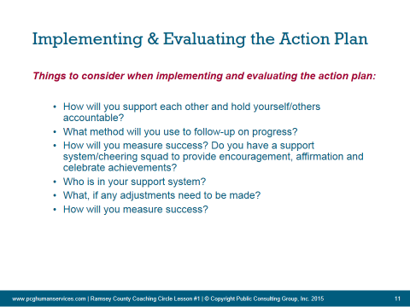 |  | Follow through  Now that the Action Plan is complete it’s time to get started working toward achieving your goals.  Follow-Up  Follow up on the action plan regularly. Find a partner to help you stay on track in achieving your goal.  Keep track of what you've done and how well you’re doing. Regularly ask yourself, “Am I doing what I said I would?” “How well am I doing?” Does anything need to be change?”  Celebration:  Remember to celebrate your accomplishments. Each milestone toward achieving your goal should be celebrated. Celebration will help keep you motivated!

Action Plan Development - Coaching for Success

