Overview

The guide will assist Coaching Circle leaders in facilitating a discussion to increase self-awareness and self management, core components of Emotional Intelligence. Self-Awareness helps us better understand our clients and ourselves. Self-Management is the ability to regulate or redirect disruptive impulses and feelings, the ability to suspend judgment and to think before acting. Without strong EI, many of the coaching or MI techniques may fall flat.

Facilitators will work towards the following objectives:
- Discuss Self-Awareness and Self-Management as a core part of working in social services.
- Build self-awareness and focus on the mindsets and philosophies that underpin BOTH MI and Coaching, rather than focusing on them as separate techniques.
- Facilitators should take the quiz themselves first, so that they are comfortable with the format and content of the website, quiz and worksheet.
- Note: more time may be required for deeper conversation. Consider your audience and whether it makes sense to have staff take the quiz ahead of time.

Total Time Needed:
- 1 hour (more may be required depending on the audience).

MATERIALS
- Computers or data-capable mobile phones where staff can take an online assessment
- Copies of the attached worksheets

CIRCLE OUTLINE:
Activity | Description | Approximate Time
Warm-up | - This should be a fun activity that gets people talking, comfortable and moving. It can be unrelated to the rest of the content. Choose your own warm-up or ask another person at your agency to run this part of the session. Keep it short, fun and simple. | 10 minutes
Introduction | - State that being self-aware is a key part of developing a person-centered approach. Self-awareness is recognizing your emotions and their impact, identifying your strengths and limitations, and knowing your worth and capabilities.  - Today is meant to give you an opportunity to self-reflect using popular self-reflection tools. Additionally, you will start to apply self-reflection to self-management. Most of the session will be done independently and you will get in pairs at the end of the day to discuss. When you come back together, this will give you an opportunity to build self-management through transparency and to learn best practices from others. | 5 minutes
16 Personalities Quiz/Worksheet | - Hand out the worksheet the activities.  - The facilitator should note that this will give you another data point about who you are and what makes you tick. This activity is based on Myers-Briggs, but is not officially MBTI (because those tests aren’t free). Let the group know that most MBA programs and leadership development workshops include quizzes like this one, because they encourage self-reflection and self-knowledge, which is considered critical in professional services.  - Provide the following instructions.  - Each person needs a computer or data-capable mobile device and will navigate to: https://www.16personalities.com/free-personality-test  - Each person will take the quiz (12 minutes)  - After getting the quiz results, each person should read “introduction,” “strengths and weaknesses” and “workplace habits” sections. While reading, they should fill out their worksheets. | Quiz and worksheet: 35 minutes
Discussion | - Get in pairs and discuss the worksheet. | 10 minutes
Send-off | - Final parting words should be brief. For example, remind group that the purpose of today was to provide time to build on self-awareness and start to think about how this increased self-knowledge can help us build self-management. Emphasize that awareness means noticing. It doesn’t mean passing judgement on ourselves or others. | 1 minute

Worksheet: 16-Personalities Quiz and Reflection

PURPOSE: This is another tool to help you think about who you are and how you navigate through your personal and professional life. This tool is useful because it recognizes that for every strength we have, there are corresponding weaknesses. Note that this is based off of Myers-Briggs Type Indicator tests. However, it is slightly different. We are using this version because it is available for free.
DIRECTIONS:
- Go online to https://www.16personalities.com/free-personality-test
- Take the 12 minute, free online assessment. Follow the instructions of the assessment
- Once completed, you will automatically be given a set of letters along with a persona “type.” Write those down in the reflective tool below and then press the red “start reading” button.
- Use the reading to complete the reflection tool below. If you are short on time, directly navigate to “Introduction,” “Strengths and Weaknesses,” and “Workplace Habits.”
- After you have finished completing the worksheet, discuss with a partner. Consider how this can help you build self-awareness and self-management at work.

REFLECTION ON QUIZ RESULTS
My five letters and personality type are: ___________________________________________________.
The quiz results say that I have the following strengths:
- _________________________________________________________________________.
- _________________________________________________________________________.
- _________________________________________________________________________.
The quiz results say that I have the following weaknesses:
- _________________________________________________________________________.
- _________________________________________________________________________.
- _________________________________________________________________________.
These strengths and weaknesses impact my work with participants in the following ways:
- _________________________________________________________________________.
- _________________________________________________________________________.
- _________________________________________________________________________.
Based on the quiz results, I can see that emotions affect me at work in the following ways:
- _________________________________________________________________________.
- _________________________________________________________________________.
- _________________________________________________________________________.
Based on the quiz results, I feel comfortable and confident that I am:
- _________________________________________________________________________.
- _________________________________________________________________________

Review this version of the Emotional Intelligence quadrants:
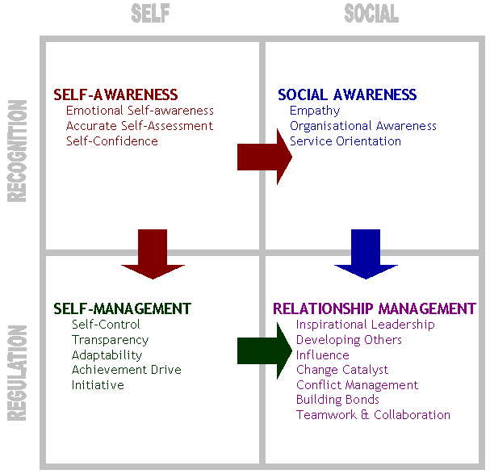
Brainstorm ways that your increased self-awareness can help you in self-management.
For example: one of your weaknesses could be that you are “vulnerable to criticism.” If so, you may have identified that that is impacts your work because it hurts and distracts you when clients or supervisors criticize you. What are some methods you can use to help you control this feeling or adapt? Perhaps you could seek to recognize criticism as fleeting opinions rather than as immutable facts.
____________________________________________________________________________
____________________________________________________________________________
____________________________________________________________________________
____________________________________________________________________________
____________________________________________________________________________

http://www.sonoma.edu/users/s/swijtink/teaching/philosophy_101/paper1/goleman.htm

